[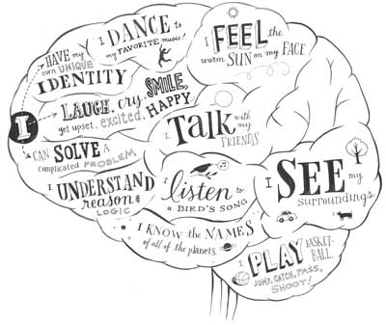](http://www.google.ca/url?sa=i&rct=j&q=&esrc=s&frm=1&source=images&cd=&cad=rja&docid=WmDR0YKrAigKMM&tbnid=-yLH9NloNzXTiM:&ved=0CAUQjRw&url=http://theonegirl.edublogs.org/2011/10/04/our-confusing-brain/&ei=P9J6Uq2CPMekrQHsmIBY&bvm=bv.55980276,d.cWc&psig=AFQjCNFgRY9CsBc2nC7Jq6EQLCTC5VMqTQ&ust=1383866585332319)**C:\Users\Casey\AppData\Local\Microsoft\Windows\Temporary Internet Files\Content.IE5\9PJRWWYX\MC900196320[1].wmf ⬩introduction to The Brain⬩**

**MODULE 5**

What is the most amazing thing in the universe? You may have your own opinion, but a lot of people would say – the brain!!! All art, music, literature, math, science, architecture and a lot more that has been created, began in the brain. A brain can even think of itself in an effort to understand itself. In isolation, no one part of the brain would be capable of anything, *but functioning together*, the parts of the brain form an integrated whole with remarkable abilities.

***Frontal lobe – this part of the brain is a lobe found at the front of the brain and controls thinking and creating. For example – problem solving, reasoning, emotions, personality. This part of the brain enables your most advanced cognitive abilities, such as judgement and planning. It also connects with the limbic region where roots of emotion are found. This means that both emotion and reason are going to influence the decisions you make.***

***Look on your diagram where it says motor - this is the motor cortex – it is on the rear edge of the frontal lobes that controls voluntary movements of your body parts.***

***Parietal lobe – this lobe helps us find our way and recognize objects and their uses and experiences sensations – such as pain, pressure, touch, and temperature.***

***Occipital lobe – this part of the brain is a lobe found at the back of the head. It is here that messages from the eyes are interpreted. ** You may not have eyes at the back of your head, but you do see with the back of your brain\*\****

***Temporal lobe – this lobe is found next to our ears. It helps us hear, plan our speech, and remember – hearing, language and speech.***

***Cerebellum – (Latin for little brain) this part of the brain helps to control balance and coordination or physical skills. The cerebellum also controls memories for knowing how to use your body for things like walking or playing the guitar. If your cerebellum were damaged, you could still decide to move your feet but you would lose much of the coordination and balance required for dancing well.***

***Brainstem – this part of the brain connects the rest of the brain to the spinal cord and regulates basic body functions – heartbeat, breathing, circulation and swallowing. This is the oldest part and central core of the brain.***

MC900334236[1]***You may have heard of the medulla – located at the base of the brainstem and it controls basic life-support functions – damage in this area would almost certainly lead to death. Another part of the brainstem is the reticular formation and it is a nerve network that plays an important role in controlling wakefulness and arousal. Damage to this area would cause a coma.***

Humans share many brain features with other animals. These brain structures are less complex, and evolutionarily older, as they evolved first. Our higher order thinking, such as abstract planning, logic, meta-cognition (thinking about thinking!), self-awareness, language, and many of the other things that seem to divide us from other animals, take place in the more recently evolved **Cerebral Cortex.** It is this part of the brain that we usually picture when we envision the brain, because it is the thin layer of bumpy tissue which covers the lower brain structures like a blanket.

**🙛Lower-Level Brain Structures🙙**

The innermost structures of the brain are the **Brainstem,** the **Thalamus,** the **Cerebellum,** and the **Limbic System.**

Some of these structures are divided up even further. For example, the **Brainstem** includes the **Medulla** and the **Reticular Formation.**

The **Limbic System** contains the **hypothalamus,** the **hippocampus,** and the **amygdala.**

1. **Brainstem:**
   1. **Medulla:** Controls heartbeat, breathing, circulation, swallowing.
   2. **Reticular Formation**: Controls wakefulness and arousal.
2. **Thalamus:** all senses (except smell) go here and then route to the proper place.
3. **Cerebellum**: Controls voluntary movement and balance, fine movement,

coordination, emotions, hearing, touch, physical memories.

1. **Limbic System:**

a. **Hypothalamus:** Hunger/Thirst, Fight/Flight, Body Temperature, Emotion,

Pleasure, Sexual function.

b. **Hippocampus:** Helps process new memories for permanent storage.

c. **Amygdala:** Controls emotional responses, especially fear and anger.

[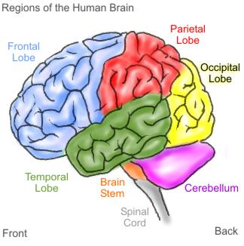](http://www.google.ca/url?sa=i&rct=j&q=&esrc=s&frm=1&source=images&cd=&cad=rja&docid=vgj00KEyA-bpDM&tbnid=1IdkHJo8JnkN3M:&ved=0CAUQjRw&url=http://www.science.ca/scientists/scientistprofile.php?pID=273&ei=rtF6UuGIOoqZrQG-yoCQBQ&bvm=bv.55980276,d.cWc&psig=AFQjCNFgRY9CsBc2nC7Jq6EQLCTC5VMqTQ&ust=1383866585332319)[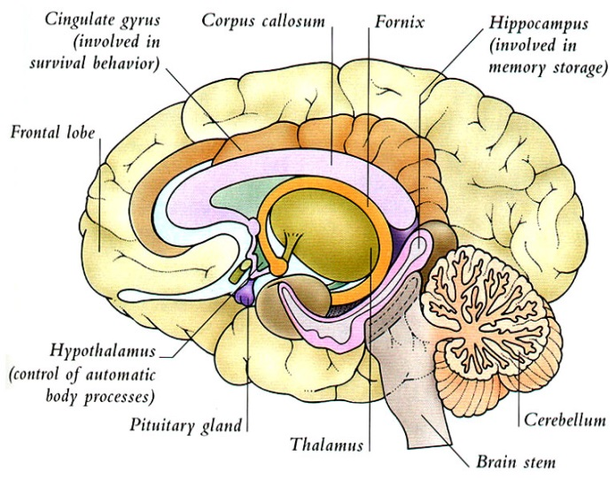](http://www.google.ca/url?sa=i&rct=j&q=&esrc=s&frm=1&source=images&cd=&cad=rja&docid=RCc2voX02-gthM&tbnid=Qoz3PYiAxS_5HM:&ved=0CAUQjRw&url=http://mccabism.blogspot.com/2010/04/ron-denniss-brain-transplant.html&ei=ps96UvPDGtShqwGhqoC4CQ&bvm=bv.55980276,d.cWc&psig=AFQjCNFgRY9CsBc2nC7Jq6EQLCTC5VMqTQ&ust=1383866585332319)