Intelligence Module
What is Intelligence?
The ability to learn from experience, solve problems, and use knowledge to adapt to new situations.

Howard Gardner (1943)
Author of theory of multiple intelligences.
-Argues that there are at least
8 different types of intelligence
Gardner’s Types of Intelligence:
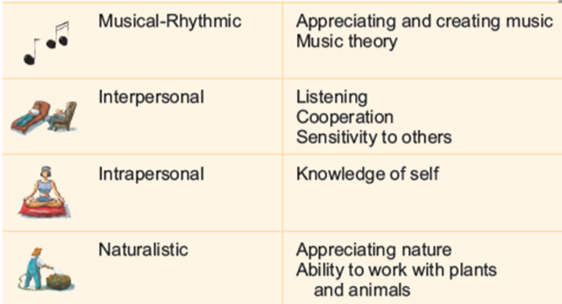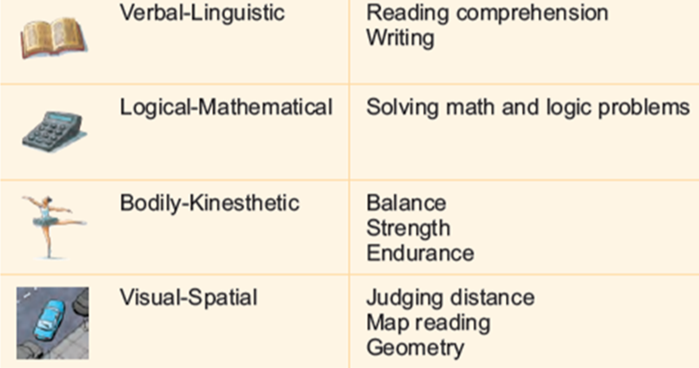

Robert Sternberg (1949-
3 different intelligences:
1. Analytic
· Traditional view
· Stressed in Schools
2. Creative
· New ideas
· Adapt to new
3. Practical
· Common Sense
· Apply, Use, Do

Emotional Intelligence:
· In touch with feelings of self and others

Another theory of intelligence, distinguishes between academic and emotional intelligence.

Academic skills seem different from social skills that flow from emotional intelligence. Perhaps this is why academically bright people are not much better than average folks when it comes to success in occupations, marriages, child‐rearing and maintaining mental health.

Intelligence Testing
Even though intelligence tests are widely used, there is much misunderstanding about what the
tests can, and cannot, tell us.

Alfred Binet (1857-1911)
• Developed first intelligence test to classify children‛s abilities using the concept of mental age.
Mental Age :
• Chronological age that corresponds to difficulty of questions a child can answer.
Ex: Theoretically, average 8yearold has mental age of 8 years.
Chronological Age:
• Actual age of a person

William Stern (1871 - 1938)
Intelligence is calculated using mental age (from intelligence test) and chronological age.
Intelligence Quotient:
IQ score = (MA/CA) x 100

Average Inteliigence is 100
Range between 85-100

The following terms were once used as medical terminology but are no longer considered derogatory and have been replaced:
"idio" (idiot) "lacking professional skill" or "incapable of ordinary reasoning" IQ = 025 Mental age = 03
"imbecillus" (imbecile) = "weak" or "weak minded" IQ = 2650 Mental age = 37
"moros" (moron) = "dull" IQ = 5170 Mental age = 712 Mild intellectual disability

Mensa top 2 percentile (130 and higher)
IQ scores are useless unless obtained from a valid standardized test
Mensa test: $40USD... practice tests online ... about 100,000 mensans in 100 countries

General Intelligence:
· Factor believed to influence all intelligences.
Charles Spearman called this factor 'g'. Idea that if you are smart in one way, you tend to be
smart in many/all other ways.

WESCHLER INTELLIGENCE SCALE
•Intelligence test, developed by David Weschler which included:
–Different tests for different age groups
–Separate scores for verbal and nonverbal abilities
–Subtests
Most Widely Used Intelligence Test In The US

Types of Tests
Achievement Tests:
- Measure what's been accomplished.
- Learned Prior, more direct
Ex: Schools
Aptitude Tests:
- Predict future performance.
- CAN do, broader range
Ex: SAT
Types of Tests of Intelligence
A Fair Test Must Have:
Reliability
· the extent to which a test yields consistent results.
Ie: If a test is reliable, then the results will be the same
no matter who gives the test.
Validity
· Extent to which a test measures or predicts what it is
supposed to.
Example: What if I designed a test to measure your intelligence
by checking your hat size? It would be reliable.. but not valid

